NAME: CLASS: Mark: 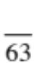

Achievement Standards being tested
Describe models of energy transfer and apply these to explain phenomena.
Mark | ND | NW | C | HC | O
Mark Range | 0-17 | 18-26 | 27-39 | 40-46 | 47-63

Content being tested
Forms of energy can be transferred in a variety of ways through different mediums (ACSSU182)
- exploring how and why the movement of energy varies according to the medium through which it is transferred
- investigating the transfer of heat in terms of convection, conduction and radiation, and identifying situations in which each occurs
- exploring situations where energy is transferred in the form of waves, such as sound and light
QUESTION | ANSWER
1
2
3
4
5
6
7
8
9
10
11
12
13
14
15
16
17
18
19
- investigating how the human body receives sound and light waves
----------------------------------------------------------------------------------------------

1 If you put a hot brick into a bucket of cold water, heat transfers from the:

A water to the brick
B brick to the air
C brick to the water
D air to the water

2 During heat transfer by convection:
(Hint: Think about heating a beaker of water.)

A energy transfers through a substance, but none of the substance
itself moves
B energy transfers through liquids and gases by tiny currents that carry
the energy
C energy transfers across empty space or through another substance
without heating it
D conduction and radiation always occur as well

3 A substance is needed to transfer heat energy in the case of:

A radiation but not conduction or convection
B conduction but not convection or radiation
C conduction and convection but not radiation
D radiation and conduction but not convection

4 The electromagnetic energy we sense as heat is:

A infrared
B ultraviolet
C microwave
D light

5 The three smallest bones in the human body are found in the:

A brain
B foot
C finger
D ear
6 A sound wave consists of:

A conductions and resonances
B compressions (high pressure areas) and resonances
C conductions and rarefactions (low pressure areas)
D compressions (high pressure areas) and rarefaction (low pressure areas)

8 The cochlea is:

A a snail-shaped bone in the ear that is the sound detector
B a thin skin covering at the end of the ear canal
C the ear flap made of spongy tissue called cartilage
D the hearing nerve that carries sound information to the brain

9 Sound energy is:

A energy in moving objects
B energy stored in objects that are raised
C energy released by vibrating objects
D energy stored in the nuclei of atoms

10 The part of the eye that contains specialised cells that convert light signals into electrical signals so we can see is the:

A iris
B lens
C retina
D optic nerve

11 Thunder is heard after lightning is seen because:

A lightning occurs before thunder.
B eyes see faster that ears hear.
C sound travels slower than light.
D the clouds slow down the thunder, but clouds do not slow down lightning.

12 A sound wave consists of a series of alternate regions of high and low pressure called:

A vibrations.
B alternating frequencies.
C different media.
D compressions and rarefactions.

Questions 15 - 17 refer to the following diagrams.

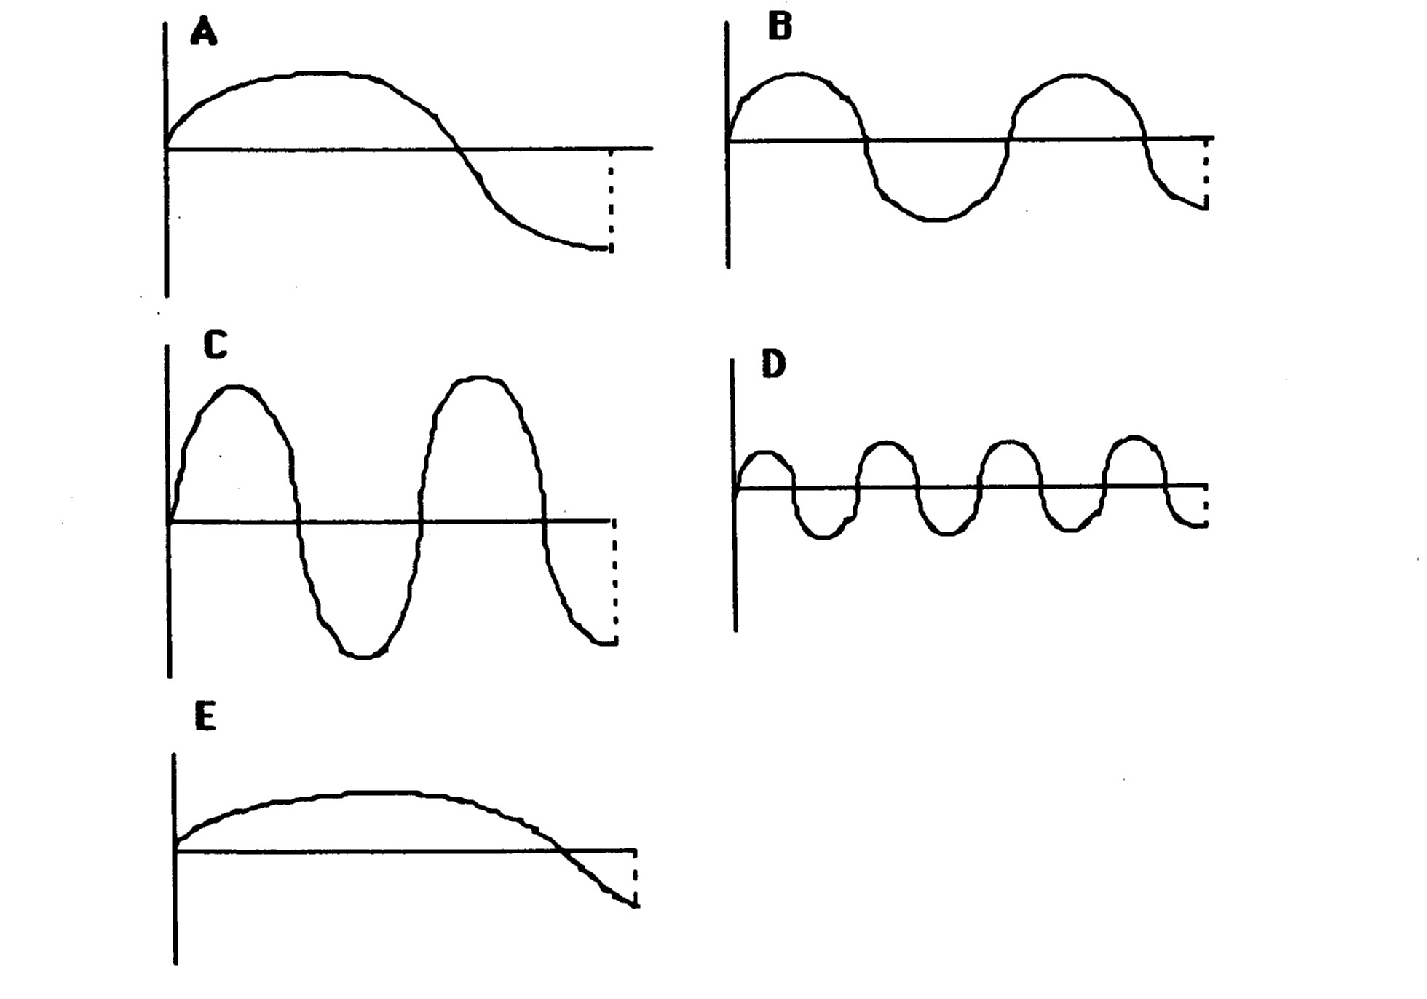

13 Which wave has the lowest frequency?

A A
B B
C C
D D
E E

14 The wave with the greatest wavelength is:

A A
B B
C C
D D
E E

15 The wave with the greatest amplitude is:

A A
B B
C C
D D
E E

16 Refraction of light is:

A the wave motion of light as it passes through a substance.
B the bending of light as it passes from one substance into another.
C a reflection of light rays at the surface of a medium.
D the failure of light to pass through a very dense substance.
E none of the above.

17 The greater the curvature of a convex lens:

A the more it bends light and hence the shorter the focal length.
B the more it bends light and hence the longer the focal length.
C the less it bends light and hence the shorter the focal length.
D the less it bends light and hence the longer the focal length.

18 Light travels in _____ lines.

A diagonal
B curved
C horizontal
D straight

19 A person standing on a bank beside a river attempting to spear a fish under the water must aim:

A below the apparent position of the fish because light rays coming from the fish are refracted
away from the normal when passing into the air.
B below the apparent position of the fish because light rays coming from the fish are refracted
towards the normal when passing into the air.
C above the apparent position of the fish because light rays coming from the fish are refracted
towards the normal when passing into the air.
D above the apparent position of the fish because light rays coming from the fish are refracted
away from the normal when passing into the air.

SHORT ANSWER SECTION - Write your answers directly on the paper in pencil or pen.

20 Draw the path of the rays in the following diagrams.

l
a
g
l
a

(10 marks)

21. Label the compressions and rarefactions in the diagram below. (1 mark)
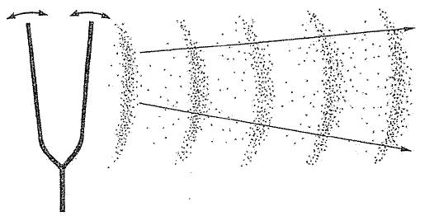

(2 marks)
22. Using the particle model theory (all matter is made up of particles), explain why sound travels at
different speeds in a solid (like steel) and a gas (like air).
(Hint: Think about how the particles are arranged in a solid and a gas.)

(2 marks)
23 What is meant by the frequency of a sound wave?

(1 mark)
24 What is the unit of frequency? ________________________________ (1 mark)
25 What unit is sound measured in? ________________________________ (1 mark)

26 What happens to the sound produced by a sound generator if the amplitude is increased?
(1 mark)
27. What happens to the sound produced by a sound generator if the frequency is increased?

(1 mark)
28. Fill out the table below. List all the structures as well as the functions of the selected parts.
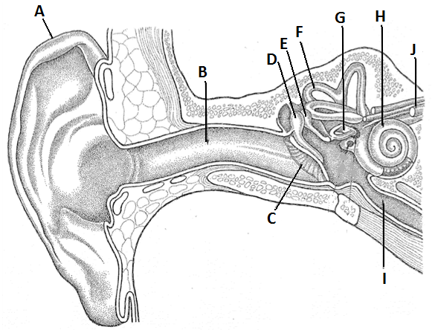
Cochlea, Eustachian tube, Ear flap, Ear drum, Semi-circular canals, Auditory nerve, Ear canal, Hammer, anvil and stirrup.
(10 marks)

Letter | Name | Function
B
C
D, E, G
F
H
29 Why can no one hear you scream in space?

(2 marks)
30 (a) Describe how the particles move in a transverse and a longitudinal wave?

Transverse

Longitudinal

(2 marks)

(b) Which of these describes the travel of sound?

(1 mark)

31 (a) Describe how the particles move in a cold piece of metal.

(1 mark)

(b) Describe how the particles move in the same metal after being heated by a Bunsen burner.

(1 mark)

(2 marks)
32 (a) Which object contains the most thermal energy - a mug of hot chocolate at 50°C or a household hot water tank at 50°C?

(1 mark)
(b) Explain your choice in part a.

(1 mark)
33 A vacuum flask is designed to keep liquids hot. Match the design features of the flask with the way in which they cut down heat loss using lines between the columns.

Design feature | How it cuts down heat loss
Tight-fitting lid | Insulation; reduces heat loss by convection
Double glass walls | Insulation; reduces heat loss by conduction
Vacuum (no particles) between the two glass walls | Reflects radiant heat and reduces heat loss through the walls
Silver lining | Reduces convection in the air space above the liquid

(4 marks)

34 A group of students placed thermometers under squares of black paper, white paper and aluminium foil of equal sizes. They recorded the temperatures shown by the thermometers every minute for
5 minutes and obtained the following results:

Time (minutes) | Temp. square 1 (°C) | Temp. square 2 (°C) | Temp. square 3 (°C)
0 | 24 | 24 | 24
1 | 25 | 26 | 28
2 | 26 | 28 | 32
3 | 27 | 29 | 35
4 | 28 | 30 | 40
5 | 29 | 31 | 45

Which of the squares is black in colour, and which one is white? (Use numbers 1, 2 or 3)
Black
White (2 marks)
35 (a) Label the following parts of the eye.

Lens, Pupil, Blind spot, Iris, Optic nerve, Retina, Ciliary muscles

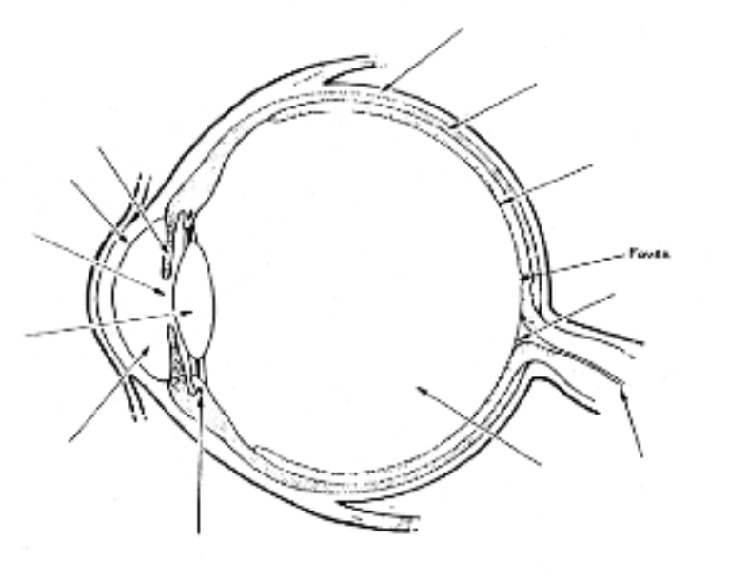
(6 marks)

(b) Draw the shape of the lens for looking at a close object.

(1 mark)
(c) Explain how the ciliary muscles work to change the shape of the lens.

(1 mark)

